VENN DIAGRAMS
Pearson Edexcel – Thursday 4 June 2020 - Paper 2 (Calculator) Higher Tier
1.
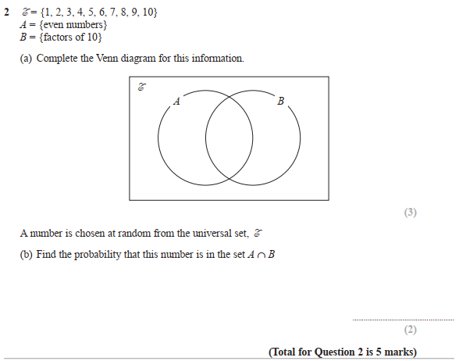

Pearson Edexcel - Tuesday 11 June 2019 - Paper 3 (Calculator) Higher Tier
2.
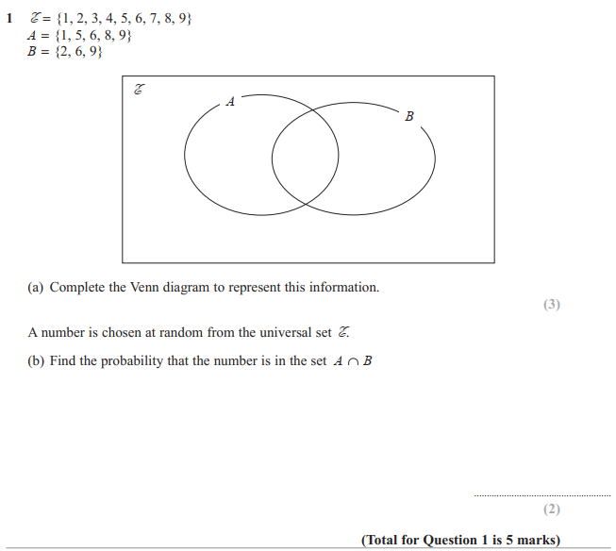

Pearson Edexcel - Thursday 8 November 2018 - Paper 2 (Calculator) Higher Tier
3.
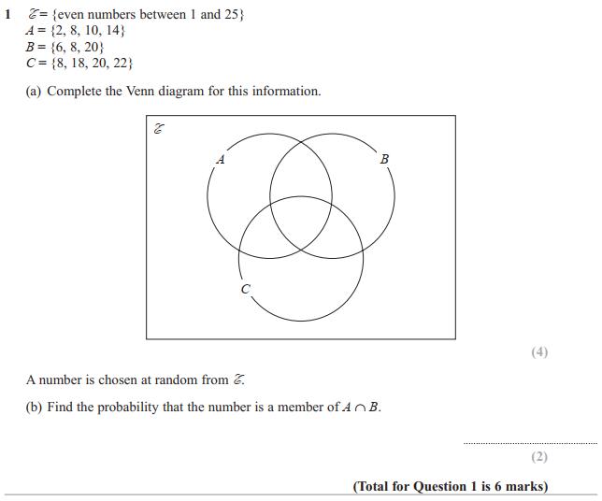

Pearson Edexcel - Tuesday 13 June 2017 - Paper 3 (Calculator) Higher Tier
4.
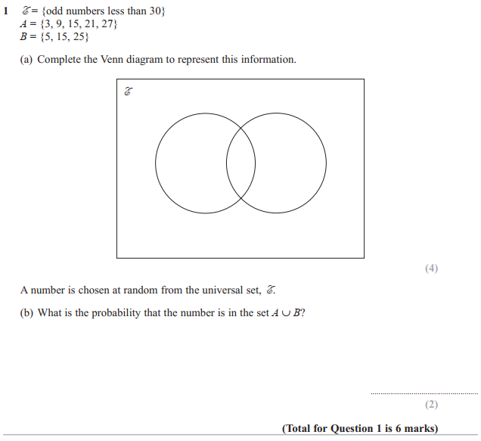

Pearson Edexcel - Specimen Papers Set 2 - Paper 2 (Calculator) Higher Tier
5.
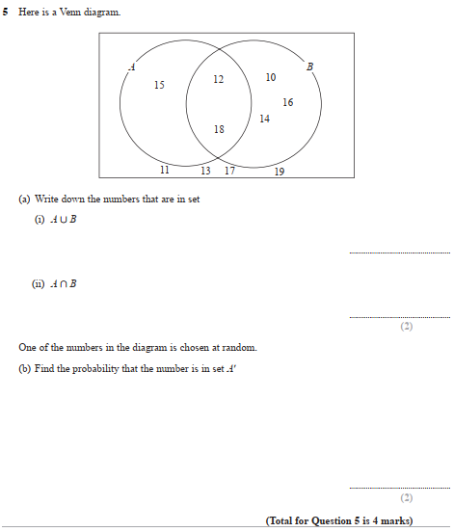
OCR GSCE – Tuesday 3 November 2020 – Paper 4 (Calculator) Higher Tier
6.
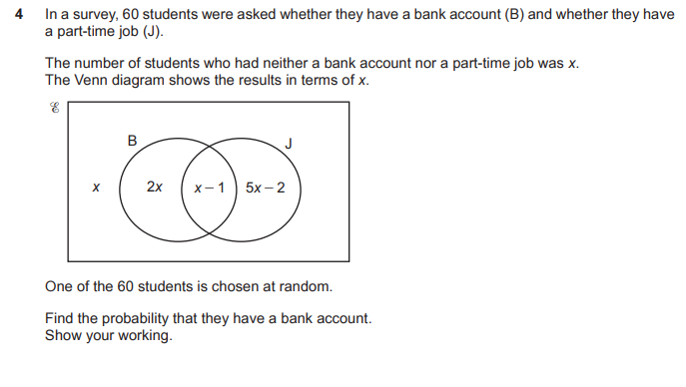

OCR GSCE – Tuesday 6 November 2018 – Paper 4 (Calculator) Higher Tier
7.
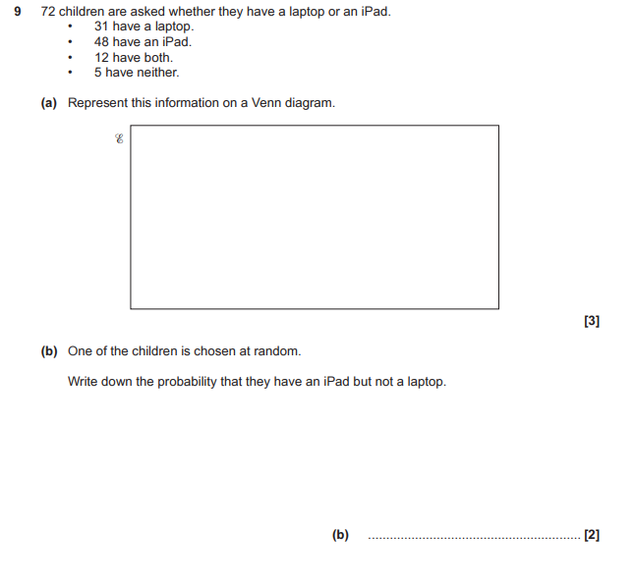

OCR GSCE – Thursday 24 May 2018 – Paper 4 (Calculator) Higher Tier
8.
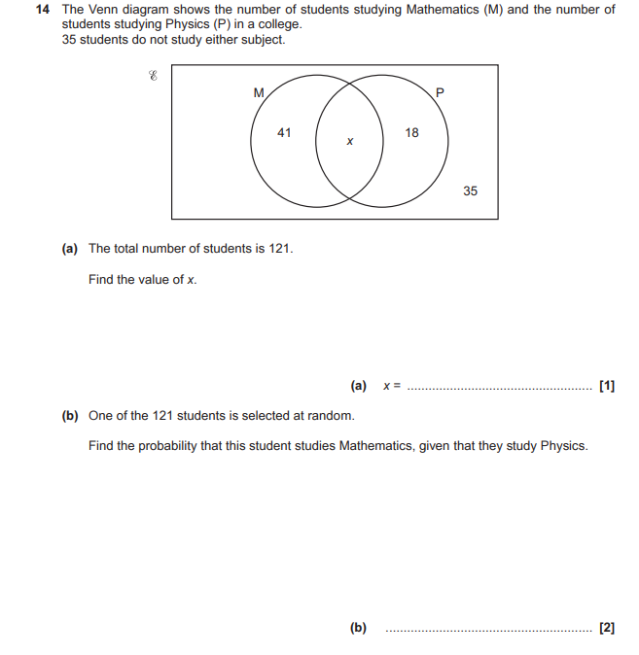

OCR GSCE – Sample Papers – Paper 6 (Calculator) Higher Tier
9.
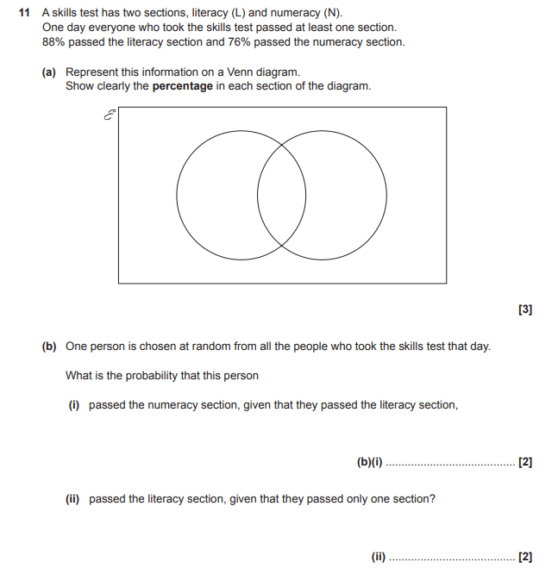

AQA GSCE – Tuesday 19 May 2020 – Paper 1 (Non - Calculator) Higher Tier
10.
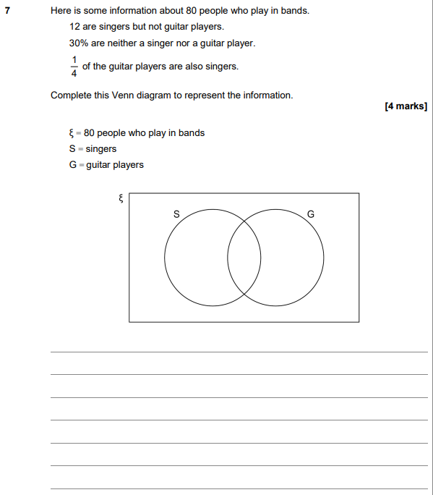

AQA GSCE – Thursday 8 June 2020 – Paper 3 (Calculator) Higher Tier
11.
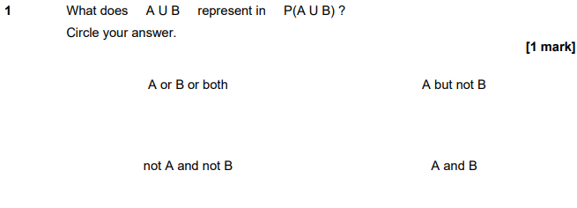
AQA GSCE – Thursday 6 June 2019 – Paper 2 (Calculator) Higher Tier
12.
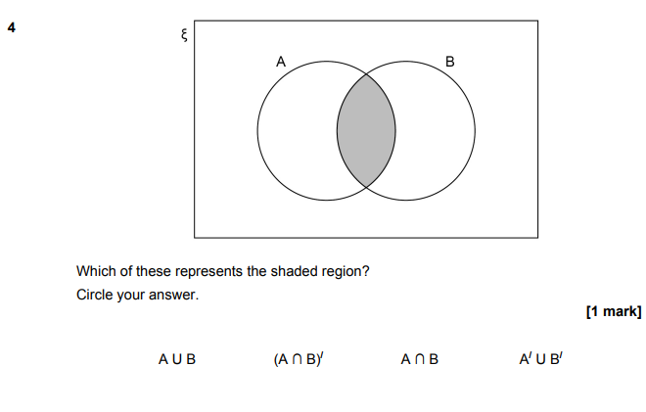

AQA GSCE – Tuesday 11 June 2019 – Paper 3 (Calculator) Higher Tier
13.
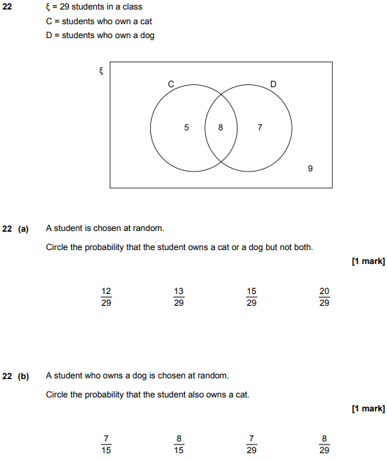

AQA GSCE – Thursday 7 June 2018 – Paper 2 (Calculator) Higher Tier
14.
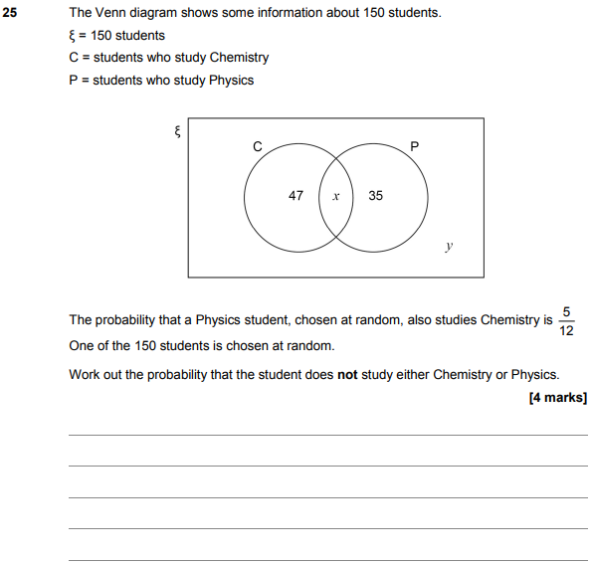

AQA GSCE – Thursday 6 November 2017 – Paper 2 (Calculator) Higher Tier
15.
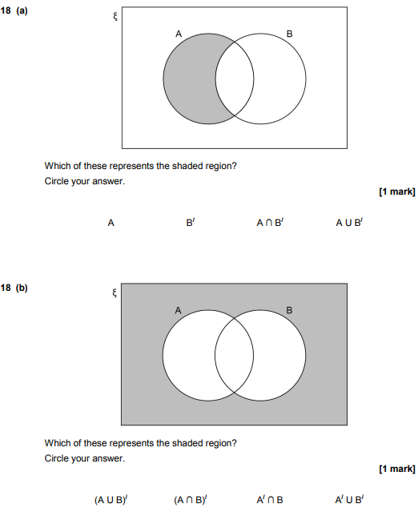

AQA GSCE – Wednesday 8 November 2017 – Paper 3 (Calculator) Higher Tier
16.
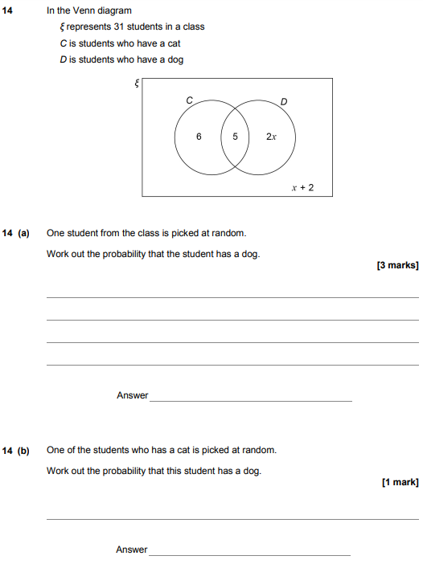

AQA GSCE – Thursday 8 June 2017 – Paper 2 (Calculator) Higher Tier
17.
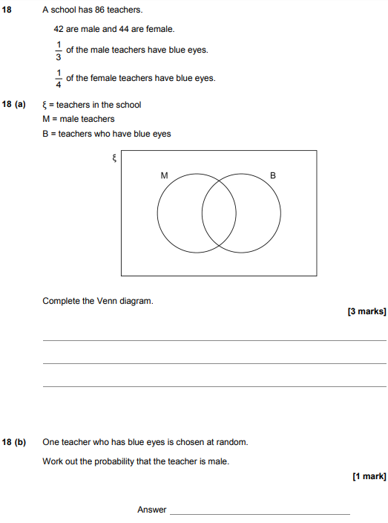

AQA GSCE – Sample Paper 2 (Calculator) Higher Tier
18.
